**Week1 Assignment**

**Git-hub:**

**A)**

1.change directory to root project and do git init command



2.

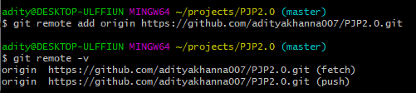

3.

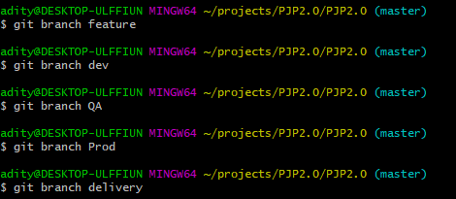

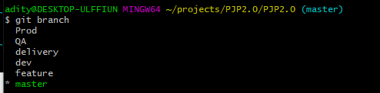

4.

**git checkout feature**

**git push origin feature**

**git checkout dev**

**git push origin dev**

**git checkout QA**

**git push origin QA**

**git checkout Prod**

**git push origin Prod**

**git checkout delivery**

**git push origin delivery**

5.

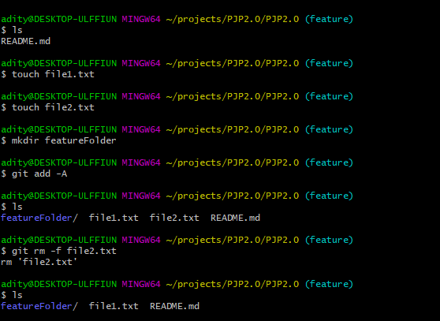

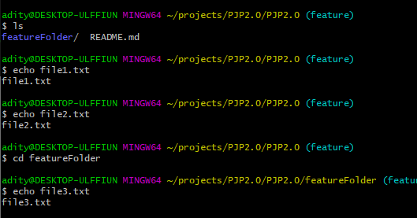

**git rm –r featureFolder // remove folder**

6.

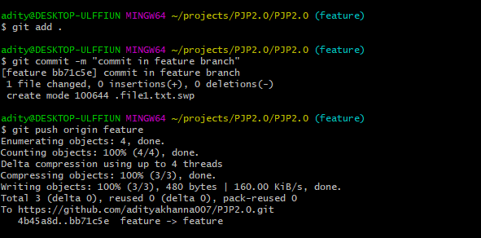

7.

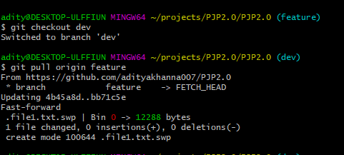

8.

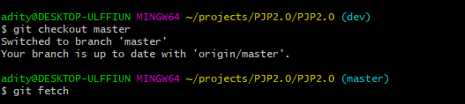

9.

git pull contacts the remote repository identified by origin and looks for updates. It fetches any updates and then merges the changes into the target branch

git checkout -b <branch> origin/<branch> creates a new branch based on origin/<branch> , and does not contact the remote repository.

10. Creating Conflict

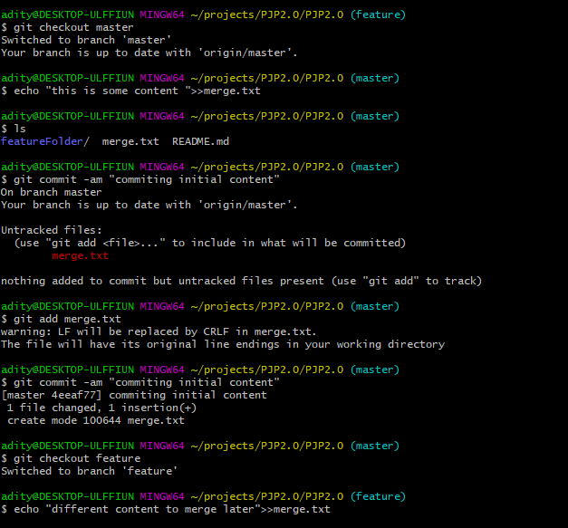

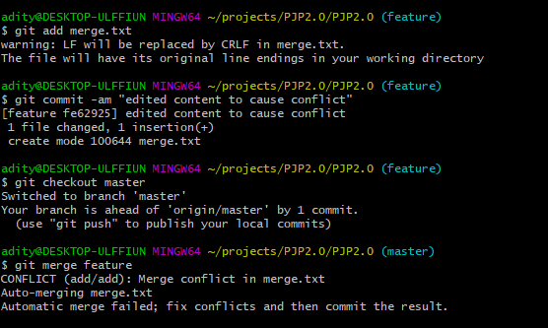

Resolving conflict

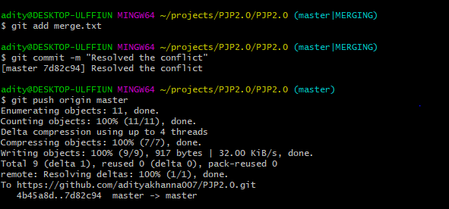

11.

Updating all branches with the master branch

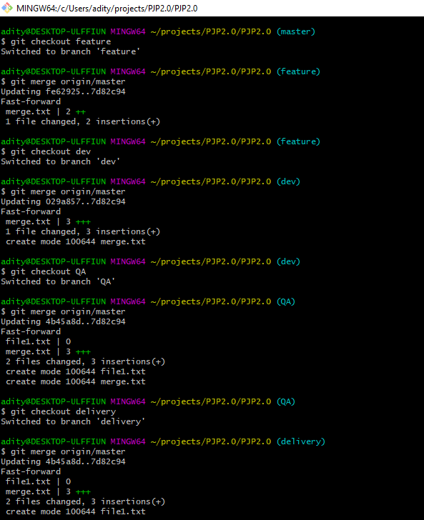

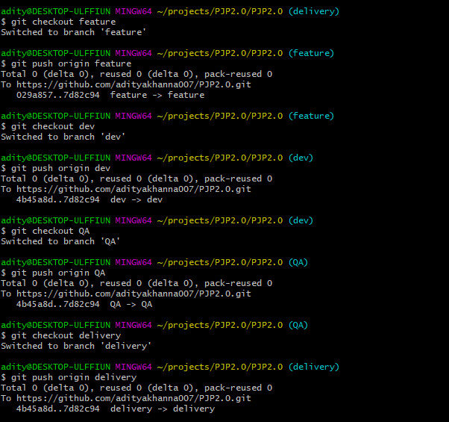

**B)**



